# CS 3733 B 2019 **Star Trek Original TV Series Mash-Up** Group Project

Have you ever been impressed by the video mash-ups you can find on YouTube?

|  |  |  |
| --- | --- | --- |
| [link](https://www.youtube.com/watch?v=0cJFjLoiSOc) | [link](https://www.youtube.com/watch?v=sZt6eU5REN8) | [link](https://www.youtube.com/watch?v=whGVHY0kC5s) |
| Ice Ice Baby (Vanilla Ice) Using Game Of Thrones | A Christmas Song Star Trek TNG | Have yourself a merry little Christmas (Bill Belichek) |

Don’t you want to make one of your own?

|  |
| --- |
| [link](https://web.cs.wpi.edu/~heineman/cs3733/) |
| I Hope That You’ll take Software Engineering with Me, George Heineman |

OK, so we don’t have the most sophisticated editing tools, but we can at least we can keep ourselves entertained as we work on this project.

Here is your team goal for this project:

* Each team will get a single DVD from the original Star Trek TV Series. I have 22 DVDs, each one containing between 1-4 episodes from this TV series. We may have to share DVDs between some teams – hopefully we can make this process straightforward
* <http://www.chakoteya.net/StarTrek/episodes.htm> contains the full screenplays for these episodes. You can find the screenplay(s) for the DVD that your team receives, so you can quickly identify sentences of interest (note: I will need the DVDs back!)
* Isolate ten video segments, each containing a full sentence from the Star Trek TV series. Upload these segments to your team library. These form your **local** video segments. The only restriction is that you need to include segments for at least THREE different Star Trek characters
* Create playlists that will play video segments in a specific order
* Provide an API to enable other student teams to access your library **remotely** soyour local video segments can appear in other teams’ playlists

My only suggestion/warning is this: don’t waste too much time on selecting the specific video segments. It took me eight hours to produce my Star Trek video above. Don’t Make My Mistake!

There is no need to consider Authorization/Account information. That is, access is granted solely from the given URLs. Anyone who participates (by invoking functionality granted by the URLs) becomes a participant. In this way you don’t have to overly complicate the system you build.

Your system consists of two different actors:

* A participant uploads **local** video segments and forms playlists containing available video segments in their designated library (which could be **local** and **remote**)
* An administrator sets up connections with remote libraries to share content

## Participant Desired Features

The participant wants to be able to carry out the following tasks:

* Create a new playlist in the library
* Show a list of existing playlists in the library
* Delete a playlist from the library
* Upload a new **local** video segment to the library
* Delete a **local** video segment from the library
* Append a **local** or **remote** video segment to the end of an existing playlist in the library
* Remove a video segment from an existing playlist in the library
* Show the ordered list of video segments within a playlist
* Show a list of **local** video segments that have already been uploaded to the library
* Show a list of available **local** or **remote** video segments that match search criteria, including (a) character to look for; (b) text to look for
* Present a web page to “play” a specific playlist. I will provide an example to show how to do this.

## Administrator Feature

The administrator is responsible for maintaining the system and would like to carry out the following tasks:

* Mark a **local** video segment so it is no longer remotely available [this doesn’t remove from any playlist]
* Unmark a **local** video segment so it can be viewed remotely again [if it exists in a playlist]
* Delete a **local** video segment from the library [same as earlier use case]
* Register third-party sites that can provide **remote** video segments. If no remote sites are registered, then a team’s playlists can only contain **local** video segments

# Architecture

In short, each team will construct a library of **local** video segments that can be appended to form a playlist. When a remote library is registered with your **local** library, then its **remote** video segments are also available to be included in a playlist.

In the diagram below, Team 2 has constructed a library with four video segments (**t3**, **t4**, **t7** and **t8**) and a single playlist **pl3**. The playlist that is delivered to Team 2’s participants contains only **local** video segments (in the following order: **t8**, **t7**, **t3**).

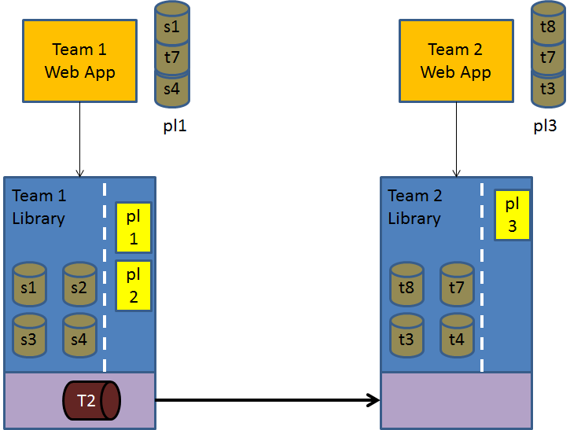

In contrast, Team 1 has registered Team 2’s library as a remote site, which means that Team 1’s playlists can contain both **local** video segments to Team 1 participants (that is **s1**, **s2**, **s3** or **s4**) and **remote** video segments from Team 2. The **pl1** playlist in Team1 has two **local** video segments, **s1** and **s4**, but also includes a third **remote** video segment, **t7**.

# Isolating Video Segments

The freely available VLC media player ([www.videolan.org](http://www.videolan.org)) is installed on the computers in the campus computing laboratories. This is helpful because these computers also contain DVD readers which will allow you to identify the video segments of interest. However, to extract the video segments, you will need to use the command line API for VLC and I will provide specific documentation on how to accomplish this. Briefly, you will use VLC to extract the segments as mp4 files, and then you will use the open source ffmpeg ([www.ffmpeg.org](http://www.ffmpeg.org)) program to convert the mp4 files into ogg files, which are suitable to be embedded within web browsers.

# Legal Implications

This project could enter some dangerous territory and so it is important that everyone follows the guidelines below for this project, based upon the doctrine of [**Fair Use**](https://cmsimpact.org/resource/fair-use-frequently-asked-questions/).

1. Did you use the work in a different manner or for a different purpose than the original “as raw material, transformed in the creation of new information, new aesthetics, new insights and understandings”?
2. If so, did you use an amount of the original work that is appropriate to your new, transformative purpose?

When you isolate a video segment the end result is to produce some creative result that transforms the original’s purpose.

Once each team has selected their ten **local** video segments to include in your library, you must submit the list of these video segments to the TA who is grading your assignment. You will state:

1. Which episode the fragment comes from
2. The length of the video fragment
3. The associated text for the video fragment

I will let the TAs use their discretion when approving a video fragment. I expect that the video segments will each be short, say less than 5 seconds for each sentence. Once your TA has signed off on the allowed video segments, then you can eventually allow them to be uploaded into your library.

Note: if during the term I discover that there is a significant body of video material uploaded to an Amazon S3 bucket I will initiate a meeting with the team and will penalize the team a **minimum of 25% of their total project grade** and may even recommend the student(s) involved to WPI’s Academic Dishonesty protocol for violating WPI’s Acceptable Use Policy. If you are ever in doubt as to whether you should upload a specific video segment, the reasonable answer is that you shouldn’t! Contact Professor Heineman if you have any questions.

Paramount has [challenged Fan-Fiction films](https://www.engadget.com/2017/01/05/star-trek-fan-film-loses-fair-use-case-moves-to-jury-trial/) in the past with lawsuits and we don’t want to invite such censure. Interested in what kinds of Star Trek lawsuits have happened in the past? [Here’s a list](https://www.trademarkandcopyrightlawblog.com/2016/07/the-pleads-of-the-many-star-trek-50-50-star-trek-litigations/). Let’s not add ourselves to the end of that list!

# End Notes

Note that if a video segment, *vs*, in a playlist, P, is changed to be marked as no longer remotely available, then *vs* is not played when P is played

As changes occur, I will amend this document and summarize those changes here.